

SCHOOL HOMEWORK POLICY

The Purpose of Homework
Homework is designed to meet the following purposes:
- To reinforce and strengthen the concepts learned in class.
- To complete unfinished class work.
- to review and practise previous learning
- To develop independent study skills and work habits.
- To develop responsibility and good time-management.
- To enhance academic achievement.

The Role of the Teacher

This may include the following:
- To set a variety of homework assignments.
- To set homework that is appropriate both to the course being taught and to the age and ability-level of the students being taught.
- To assess the homework and to provide the student with appropriate feedback.
- To communicate with parents where a pattern of unsatisfactory homework emerges.
- Differentiation of task will be allowed for mixed ability classes.
- The criteria to apply in provision of homework will concur with the ideals of both assessment of learning and assessment for learning.

The Role of the Pupil
This includes the following:
- To record all homework given in homework journal.
- To diligently carry out all homework assignments, both written and non-written.
- To seek clarification from the teacher on any aspect of the homework about which he is unsure.
- To make the homework available for correction at the nominated time.

The Role of the Parent
This includes the following:
- To support the pupil in carrying out his homework assignments by providing and environment/room that is appropriate for this task.
- To supervise the doing of homework, and to give advice and assistance as required.
- To sign the homework, if requested by the teacher.
- To assist the development of learning strategies (e.g. organisational skills, time management)

Review

This Policy was reviewed and updated in August 2025

Signed

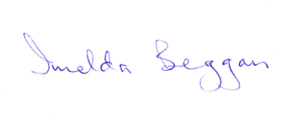

Principal Chairperson

____________________________________ __________________________________

