

SMOKE FREE WORKPLACE POLICY

Rationale:

Exposure to second-hand smoke/Environmental Tobacco Smoke (ETS) also known as passive smoking is a cause of disease, including lung cancer and heart disease, in third parties. Neither the simple separation of smokers and non-smokers within the same airspace nor the provision of ventilation can eliminate exposure to ETS and the consequent health effects of such exposure. This policy has been developed to protect all employees, service users, customers and visitors from exposure to ETS, to ensure compliance with legal obligations and to ensure a safe environment.

Policy:

It is the policy of Patrician High School that all of its workplaces are smoke-free and that all employees have a right to work in a smoke-free environment. Smoking is prohibited within the entire boundary with no exceptions. This policy applies to all employees, consultants, contractors, customers and visitors. In the school context this also applies to students and parents.

Implementation:

Overall responsibility for policy implementation rests with the Board of Management/Manager. All staff have an obligation to adhere to and facilitate the implementation of this policy. The Principal as the person in charge of the school shall inform all existing employees, consultants and contractors of the policy and their role in the implementation and monitoring of the policy. All new and prospective employees shall be given a copy of the policy on recruitment/induction by the person responsible for staff induction. All new contractors and consultants will be given a copy of the policy by the principal. Students and parents will be informed of this policy.

Infringements

Infringements by students and staff will be dealt with under local disciplinary procedures. Section 47(3) of the Public Health (Tobacco) Act 2002 states that “any person” (including an employee) found to be in contravention of the new regulations will be “ guilty of an offence” Infringements by customers, clients etc., will be dealt with in accordance with the procedure set out below. Employees, consultants, contractors, customers and visitors who contravene legislation prohibiting smoking in the workplace are also liable to criminal prosecution with an associated fine (up to €3000).

Procedure if a person smokes in contravention of Section 47 of the Public Health (Tobacco) Acts that prohibits smoking in the workplace:

- Draw the person's attention to the "No Smoking" signs and advise that they are committing an offence by smoking on the premises
- Advise the person that it is also an offence for the Board of Management to permit anyone to smoke in contravention of the law
- Advise the person that the school has a smoke-free policy to ensure a safe working environment for employees and students
- If a person continues to smoke advise them that they are in breach of school rules and that disciplinary sanctions will have to be implemented.
- Violation of the smoke free policy will invoke disciplinary procedures. Action will be in line with the procedures used for violation of any other health and safety procedure in the school.

Violation of the smoke free policy by non-school personnel (e.g. visitors, contractors, suppliers) should be dealt with in accordance with the DES Circular 18/99 ”Guidelines on Violence in Schools”.

Review

This Policy was reviewed and updated in August 2025

Signed

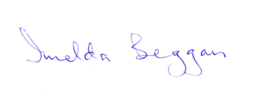
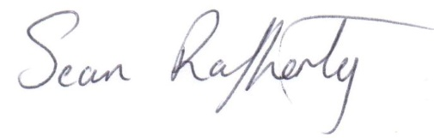
Principal Chairperson

____________________________________ __________________________________

