

WELLBEING POLICY 2025/2026

HISTORY OF OUR SCHOOL
The Patrician High School was established at the turn of the century to provide second level education for the sons of Catholic families in the area. The Viscount Weymouth Grammar School, since closed, was already well established to cater for the children and Church of Ireland families. Dean Birmingham, PP, invited the Patrician Brothers to the town to manage the school and gave them his own house (the building now known as the Old Monastery) for the purpose. The school was set up in one room in the house and one room in the backyard. There were eight pupils.
We have moved twice since then to accommodate increasing numbers. From the beginning, we have aspired towards academic excellence, and that tradition is proudly upheld to this day. Our pupils have succeeded in all walks of life, and we believe that this success is due in no small measure to the solid grounding they received in essential subjects and to the confidence that comes from the reinforcements of the sound Christian principals by which we live.
While maintaining a proud sense of tradition of academic achievement, we have never been slow to adapt to the need of a rapidly changing world. We review our courses frequently and the school has been involved recently in the working with the Department of Education in developing new courses in Woodwork, Modern Languages and Technology. We have earned a high reputation in Inter -Schools Debating and Ulster Colleges' Football. Since 1994 we have featured on the Ulster Colleges' Roll of Honour on 15 occasions and won 8 Ulster Football Titles.
Our brand-new building has been open since 2007. It has been many years in the making and required the dedication and hard work of many people in our community to realise this essential upgrade for the schoolboys of Carrickmacross. It is a superb, state-of-the-art facility, and it has contributed enormously to the teaching and learning process for all involved in our school.
Since 2007 we have continued to expand and develop our school facilities. The addition of 4 new teaching classrooms, a new Design and communication Graphics classroom, an extended and refurbished Art classroom and the addition of a new Science classroom have allowed the school to develop new and exciting short courses at Junior Cycle level. In 2018 the acquisition of a large plot of lands adjacent to the school has allowed for the development of a much-needed recreational facility for the school. The development of a school playing field and the addition of a large horticultural area have been the focus of the first phase of the development.
When developed the additional lands will allow the school to expand further and continue to provide the highest standards of teaching and learning supported by state-of-the-art modern facilities.
At present the school has over 400 pupils and over 35 staff members. The school caters for pupils from all socio-economic groups and is open to pupils of all abilities, races, and creeds.

SCHOOL MISSION STATEMENT
The promotion of the educational development and fulfilment of the educational needs of all our pupils in a secure environment.
The pursuit of the excellence in individual achievement while nurturing a growth in responsibility that will prepare pupils for their role in family and society.
The maintenance of an educational philosophy, based on our Christian principals which will guide and support our pupils through further education and the world of work.
The creation of an atmosphere within the school in which:
- Authority is respected.
- Study and achievement are promoted.
- Spirituality is encouraged.
- Environment is preserved.

A supportive partnership is maintained with parents, employers and the wider community.
The development of a school spirit, in accordance with Christian ethos, in which there is mutual support and respect between all groups involved in the school.
The development of an understanding of different cultures and minorities and a respect for all irrespective of their gender, colour, creed or nationality.
The promotion of the highest standards of teaching and learning through professional development of staff and the development of all facilities necessary to deliver an up to date and comprehensive education to our students.
The maintenance of our independence to pursue our aims whilst developing links with other educational institutions in a SPIRIT OF CO-OPERATION.

RATIONAL FOR THE POLICY
The Framework for Junior Cycle (2015) highlights the necessity for a new area of learning at Junior Cycle, Wellbeing. This policy has been developed to ensure that the Patrician High School adequately responds to the changing and diverse needs of each of the pupils.
There are already evident similarities between our own mission statement and the definition of “Student Wellbeing” as outlined in the NCCA guidelines. “Student wellbeing is present when students realise their abilities, take care of their physical wellbeing, can cope with the normal stresses of life and have a sense of purpose and belonging to a wider community” (NCCA Guidelines for Wellbeing 2018).
The purpose of this policy is to outline our approach to monitoring, encouraging, and promoting student well-being through our set curriculum, co and extra-curricular activities along with our Pastoral Care structures.
The philosophy of this policy is based on the Junior Cycle Wellbeing guidelines - planning and developing a coherent Wellbeing programme that builds on the understandings, practices and curricula for wellbeing already existing in schools. The framework for Junior Cycle (2015) provides for a new area of learning at junior cycle called Wellbeing. Wellbeing will cross the three years of junior cycle and build on substantial work already taking place in schools in support of students’ wellbeing.
This area of learning will make the school’s culture and ethos and commitment to wellbeing visible to students. It will include learning opportunities to enhance the physical, mental, emotional and social wellbeing of students. It will enable students to build life skills and develop a strong sense of connectedness to their school and to their community. The junior cycle Wellbeing programme began with 300 hours of timetabled engagement in 2017 and has increased yearly to 400 hours in 2022 as the new junior cycle was implemented fully in schools.

STRUCTURE OF OUR WELLBEING POLICY
The Patrician High School have embraced a whole-school approach and have aligned the design and planning for our Wellbeing policy with school policies, SSE, and school practice. The foundation of this policy is based on the Junior Cycle Wellbeing Guidelines and Wellbeing Indicators, the aim of which is to support schools in planning and developing consistent wellbeing programmes.
The Wellbeing policy is anchored in the following subject areas: SPHE, CSPE, PE, Guidance, other areas of learning and practices within the school. The policy will be guided by The Continuum of Support which offers a flexible framework which schools can identify and address all educational needs as well as the wellbeing needs of its students.

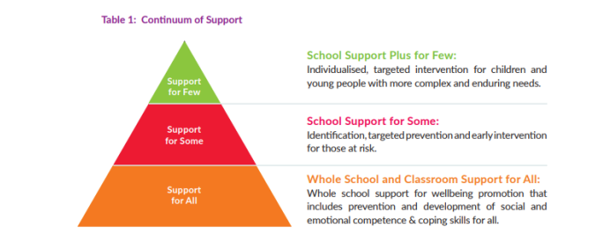

There is a clear link between Wellbeing and the provision of Guidance in our school. It is not however the sole responsibility of the Guidance and Student Care Team. It is a whole school responsibility Whole School Guidance is delivered on a continuum of support. This is where the school is broken down into three sections: support for all, support for some and support for few. Those with the highest needs will receive the highest levels of support. We also apply this model for wellbeing. All staff involved in the education of students has a role in each stage of the continuum.
Support for all involves all the students in the school. This is displayed through a positive classroom environment, ensuring students are aware of teacher expectations in the classroom, differentiated teaching where required and monitoring student behaviour. This is the first level of support to ensure that all students are supported throughout their school lives. Teachers will be the first line in screening students to ensure their educational and behavioural needs are being met. If there are any concerns identified, the teacher can refer these concerns on to a Class Teacher, Year Head, Learning Support, Student Support Team, Guidance Counsellor, Deputy Principal or Principal.
Once a student is identified and a need for extra help established, the teacher has a continued role. This involves differentiated teaching methods, continued supervision of the student’s progress, gathering information, interventions and monitoring the situation. Once a student has been identified as needing extra support they move into the next category: support for some.
Support for some involves individual support, educationally through Individual Education Plans (IEP’s), gathering information from parents, teachers, and the students themselves, behavioural support and implementing agreed strategies on a one-to-one level and in class. Progress of the student will be monitored and reviewed so that strategies can be adapted to suit the student’s needs. Some students may need further support, this is offered in the final stage, support for few.
Here students may be supported by internal and external personnel. Internally students may be supported daily by teachers and on a one-to-one basis by the Guidance Counsellor or Learning Support teacher. External help may be in the form of school-based agencies like a NEPS psychologist, engagement with CAMHS or a private counsellor.
The school plays an important role in providing learning experiences and opportunities that develop and shape the character and wellbeing of the students in our care. Experiences that develop character by promoting mindfulness (self-regulation and behaviour), curiosity, courage, resilience, ethics and leadership benefit children and young people as they grow and develop. Schools focus on giving children and young people voice, being active learners and developing strong character qualities that will enable them to succeed, thrive and contribute positively throughout life.

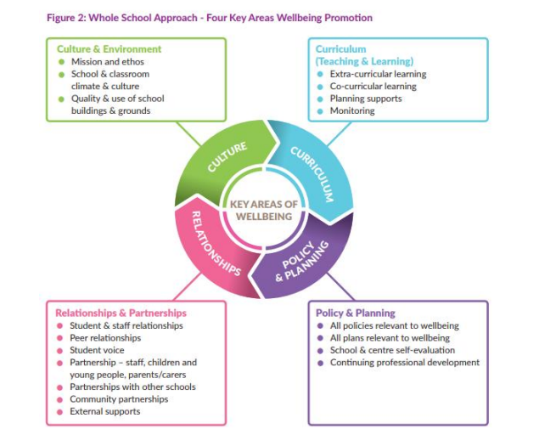
The Patrician High School aims to cater for the needs of its students. Its pastoral approach seeks to respect and nurture the quality of all relationships. It promotes effective and caring leadership and partnership in the school community. It influences all aspects of life in the school, in particular policies, curriculum, roles and structures in order to sustain and enrich the educational experience of each student and consequently that of every person in their relationship to the school.
As we have evolved, the school has developed, with the input of each component of the school community, several policies regarding issues such as Code of Conduct, Anit-Bullying, Drugs/Substance misuse, Dignity in the workplace and Acceptable Usage policy. By familiarising themselves with these policies parents will have a better understanding of the way in which the school deals with such issues and can then support their son’s wellbeing when dealing with such issues.
The school operates a class teacher and year head system. The class teacher is a teacher who, on behalf of the school community, undertakes the role of caring for a class group in order to promote learning at every level of the person. A year head is a teacher who takes on the role of overseeing the welfare of a year group, working in conjunction with the class tutors. This approach ensures that each pupil has teachers who has their well-being at heart, personal as well as academic.

ROLE OF THE CLASS TEACHER
- A class teacher is assigned to each class each year.
- The class teacher's role is purely pastoral. He/she may be consulted by subject teachers having difficulties with the class but is not expected to assume a disciplinary role.
- The class teacher helps the class to settle in and encourages class spirit and cohesion.
- The class teacher looks out for his/her class and establishes a personal relationship with students in that class.
- The class teacher may, at his or her discretion, help organise class outings.
- The class teacher encourages students who may have problems to confide in him/her or any other teacher of their choice.
- The class teacher reports class problems to the Year Head, Guidance Counsellor, Deputy Principal or Principal as appropriate.
- The class teacher reads and explains the School Rules and Disciplinary Procedures to the class.
- The class teacher encourages the class to respect the rules.
- The class teacher oversees the appointment of two prefects for the class.
- The class teacher is informed by other teachers of information relevant to the welfare of students in his/her class.
- The class teacher monitors the progress of each member of his/her class.
The class teacher does not normally meet with parents but refers them to the Year Head.

ROLE OF THE YEAR HEAD
- The Year Head will only become involved with: (a) persistent problems, (b) irregular serious problems, (c) general class problems and (d) in a Pastoral capacity.
- The Year Head will help monitor: (a) Homework journals, (b) Uniform, (c) Absenteeism, (d) Class seating plans, (e) Study and revision programmes, (f) School campaigns on issues such as litter, etc. (g) Individual students from his/her year who are on probation, (h) Staff awareness of medical problems.
- The 1st Year Head, in consultation with the Class Teacher, will have the additional tasks of class allocation in September and helping with settling-in problems, which would arise with some students. He/she might also be involved with the Guidance teacher in dealing with specific difficulties that might arise in subject choices in April/May.
- The 5th/ 6th Year Head will have the extra function, in consultation with the Class Teacher, of helping new students in that year settle in.
- The 5th / 6th Year Head may liaise with Student Council.
- Each Year Head will record persistent or serious problems involving pupils in his/her year. When only the Class teacher becomes involved, he/she will pass on the relevant information to the Year Head.
- The Year Head may, at his/her discretion, contact the parents of a student.
- The Year Heads may act as members of the discipline committee.

WELLBEING IN OUR TEACHING AND LEARNING PRACTICE
In the Patrician High School, we use a wide and varied mix of learning & teaching methodologies and strategies: Mindful of the mixed ability settings in most classes staff utilise a variety of teaching approaches and methodologies to maintain student engagement and maximise learning and achievement. Emphasis has also been placed in recent years on the integration of ICT into teaching and learning in the school. Team teaching for SEN support is also in place.
Mixed ability class grouping: apart from the banding in 2nd year of core subject; English, Irish and Maths to allow for uptake at differentiated levels. This serves to promote a sense of democracy and a sense of community in all classes. In keeping with best practice staff sees this structure as central to the promotion of student self-esteem and wellbeing.
Positive relationships: Our promotion of positive relationships is based on the recognition of the dignity of each individual and the importance of respectful relationships between teachers, students & parents. Building an emphasis on positivity and on rewarding positive behaviour enhances our student participation and school community.

SUPPORTING AND PROMOTING A CULTURE OF WELLBEING IN OUR SCHOOL
The Patrician High School promotes a warm, welcoming, encouraging, and positive school culture in the following ways:
- The physical environment conveys a message of warmth, welcome and inclusion.
- There are internal and external spaces for students to congregate socially and to have quiet time.
- The school building is accessible for all students.
- Students and staff take pride and care in maintaining the physical environment.
- The school environment is conducive to promoting physical activity, and healthy eating choices.
- Teachers have high expectations for all students.
- There are open, positive, supportive relationships between teachers and students.
- A culture of collaboration and cooperation is promoted through day-to-day teaching, learning and assessment practices.
- Students are encouraged to actively engage in their learning so that they may enjoy being at school.
- Students receive regular formative feedback about their learning and how they can improve.
- Students have regular opportunities to talk about their learning and what helps them to learn.
- Teachers use active methodologies to develop the key skills in their subjects.
- Teaching and learning are differentiated and provides an appropriate challenge to enable all students to engage and experience success.
WELLBEING INDICATORS
In the Patrician High School all teachers will support student Wellbeing by identifying areas within their subject planning that can link areas of learning to wellbeing indicators. The Wellbeing Indicators form a large section of our student diary, this is referred to daily in class by subject teachers and class teachers. The addition of a wellbeing log and a recording section for Other Araes of Learning in our student journal has also been identified as key for reflective practice when dealing with students’ wellbeing.
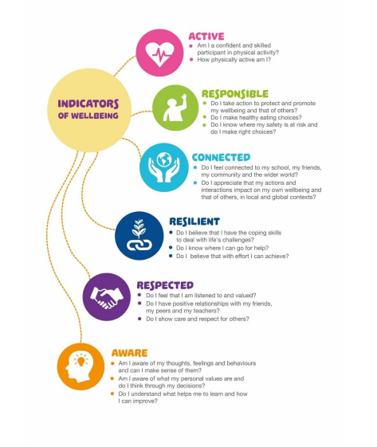
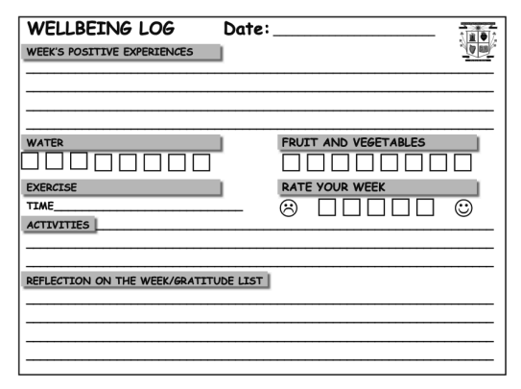

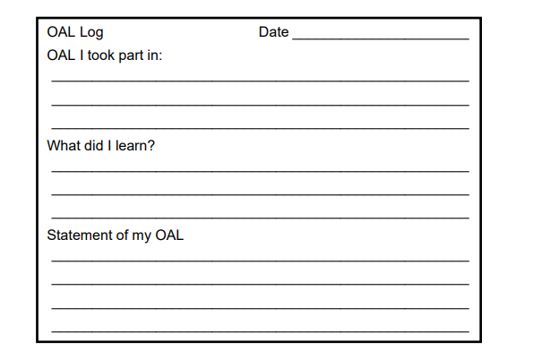

WELLBEING COORDINATOR
The Wellbeing Coordinator role was formalised in 2017. When identifying the priorities and needs of the school the staff and students identified Wellbeing and one of the key areas of concern for our school community. In conjunction with the post holder, the roles and responsibilities attached to the position are reviewed on a yearly basis. The wider school community review the position and roles on a biennial basis, thus ensuring we keep the responsibilities relevant and in line with the needs of the school community. The most recent roles and responsibilities are detailed below, it must be noted that these responsibilities must be flexible and may change throughout the school year to meet the needs of the staff and students at the school:

Roles and Responsibilities:
- Liaise with Deputy Principal on issues of Curriculum provision, Identify and record of any additional extra-curricular Wellbeing hours that are taking place in year groups.
- Student Support Team Head: Formation of Student support Team at the beginning of school year, co-ordinate one meeting per term along with meetings that will arise from referrals meetings, keeps staff informed of issues arising by updating a file on the server. Keep up to date records of students working with care team along with relevant information from cooperating teacher. Ensure regular meetings are taking place between student/teacher pairings within care team.
- Co-ordinate Big Brother little brother programme within the school. Ensuring teachers and relevant 5th year students are in place for start of year. Keep staff informed of students currently taking part in BBlb.
- Co-ordinate Well-being events throughout the school year, that will include the full school community.
- Provide one wellbeing activity/day per year for the full staff.
- Lead and Co-ordinate relevant staff CPD around Wellbeing.
- Assist Year Head and Guidance teacher with any transition issues that may arise with students entering from primary schools.
- Meet weekly with new enrolees to assist with the transition to our school.
- Facilitate student awareness campaigns around areas such as LGBT stand up week etc.

STAFF WELLBEING
Staff in the Patrician High School work in a supported environment. At Board of Management meetings, the Principal’s report keeps the board informed of the efforts and work of staff throughout the academic year. This is also formally affirmed at staff gatherings. The Staffroom has access to modern staff facilities which gives access to desktop computers, printers, photocopiers and other subject relevant technology and software that is up to date. Teacher based classrooms are in the majority and this lends to enhanced working conditions for staff. Our staffroom is well equipped and provides a communal space for staff to relax, this communal area has direct access to our canteen facilities. There is an adjacent staff workroom area also which can be used for quite time for planning or corrections.
School management work collaboratively with the whole staff. Management respects the professional commitment of each staff member. Management is understanding of the complex pressures which may come to bear on all members of staff from time to time and respond with compassion. Staff members are encouraged and supported to take on new roles, gain further qualifications or attend relevant CPD courses. Staff are encouraged to share experiences of these CPD’s within the relevant departments and with the wider staff group.
Staff are equipped with up-to-date technologies to assist with planning, teaching and learning. Each staff member has access to individual laptops and have access to a Microsoft 365 account. Each classroom is equipped with the required technologies to support teaching and learning. There are many shared student ICT devices for classroom use. Practical rooms and teaching classrooms are resourced and maintained to a high standard, helping to create a positive learning environment for staff to work in.
The Patrician High School promotes a culture of collaborative collegiality. This is achieved through regular subject department meetings, whole staff meetings, staff planning committees and a shared online network of resources on Office 365. Subject departments have access to a shared collaborative space on the school intranet. The whole school email system ensures all staff are aware of important events and opportunities.
The school has an active staff social committee which organises events periodically throughout the year to enhance personal relationships between staff members. Staff lotto draws, mystery staff weekend trips and regular staff raffles greatly contribute to a positive atmosphere in the staffroom.

STUDENT LEADERSHIP / STUDENT VOICE
Students are strongly encouraged to take up leadership roles within the school. The Patrician High School has a successful prefect structure of Head Boy, Deputy Head Boy, Senior Prefects and Class Prefects. The engagement of the student voice in actions and decisions which shape their learning environment is at the centre of our leadership structures.
The student council plays an important role in this process. Council members are elected by their peers to represent them and work with the principal and staff on the various issues and topics.

WELLBEING INITIATIVES IN THE PATRICIAN HIGH SCHOOL
- Feel Good Week: The aim of the annual health and wellbeing week is to create awareness around mental health, promote health and wellbeing, resilience, as well as adding to the positive atmosphere of the school. Ultimately it seeks to highlight what keeps us positive. Activities include information areas with posters on health and wellbeing, yoga classes, positive thoughts presentation, sporting camps, local walks and runs, talks on mental wellness/coping strategies from outside agencies.
- Music: Dedicated music rooms and the option to join school events available to all students. Our annual Concerts, school services, graduation service and visits to local community groups, gives students the opportunity to display their talents. We have also forged a strong working relationship with Music Generation, who provide regular workshops for our students.
- Lunchtime Activities: we have a wide and varied range of activities that are offered to students while on lunch break. Some teachers operate an open-door policy for their classrooms, allowing students to gather for the duration of the break. Room 4 offers a host of different engaging activities to all students who wish to attend, computer games, board games and reading corners are all sample of the activities available. Lunchtime leagues in a range of different sports are facilitated by our Transition year students throughout the academic year.
- Enterprise: in enterprise activities teachers help students make informed decisions based on careful research and analysis, setting up and running their own enterprise projects. It helps students to grasp real life skills: working as part of a team, managing production/ finances, organising a sales and marketing campaign, and liaising directly with customers and media.
- Student Workshops: we regularly facilitate student workshops to enhance wellbeing, in conjunction with outside agencies we have recently hoisted the “Be Well Programme” for all Junior Cycle Students and the “Yes” Programme for all Senior Cycle students. These programmes promote self-awareness, emotional awareness and an understanding around sexual consent issues.
- Subject weeks: help to build positive relationships, improve self- esteem, and develop transferable skills. They contribute to the wellbeing of the students by giving them the opportunity to learn in many ways. By interacting with their classmates and teachers, and by taking part in activities inside and outside the classroom, each student is challenged to problem solve outside of their comfort zone promoting positive supportive relationships within the school.
- Wall Art: students are assigned wall areas inside and outside the school. A theme for the artwork is agreed between the art department, students and school management, this project is then completed by a range of different students over the course of the academic year.
- School Library: Comfortable and welcoming environment. Open shelf policy and the use of e-books for all students.
- Big Brother little brother Programme: This matches a 1st or 2nd Year Student in need of friendship and support to a caring 5th Year volunteer mentor. They meet regularly through the school year, for an hour or two and do something they both enjoy, like kick a ball around, playing games, scavenger hunts, Quizzes, or listen to music - the possibilities are endless. Through these weekly meetings and an end of year group trip, a friendship is formed, and transformational change happens. The match between young person and volunteer is supported every step of the way by staff members.
- Check and Connect Mentoring Programme: is an intervention used with senior cycle students who show warning signs of disengagement with school and who are at risk of dropping out. At the core of Check & Connect is a trusting relationship between the student and a caring, staff mentor who both advocates for and challenges the student to keep education salient. Students are referred to Check & Connect when they show warning signs of disengaging from school, such as poor attendance, behavioural issues, and/or low grades.
- Homework & Study Club is available to all students: available after school for 10 hours per week. Students are given the opportunity to study/revise or complete homework, under the supervision of a teacher.
- Free School Breakfast Club for all students: A range of healthy options are available to all students in our school canteen from 8:00-8:30 each morning.
- SNA student supports: We currently have an allocation of 1.5 special Needs Assistants, this allocation is distributed among the students most in need of support. This support is reviewed regularly throughout the academic year.
- School Services/Ceremonies: We celebrate our Christian Ethos by hosting school events to mark important dates on the liturgical calenda. Our local church St Joseph’s celebrate an annual start of year mass and facilitate several services during the school academic year. We have a close working relationship with our local parish.
- Student Council: Enhances student voice and promotes a sense of involvement in the development of the school and a sense of partnership between students and teachers.
- Parents Council: Fundraises, organises events, assists policy development to sustain and enhance wellbeing in the school community.
- A wide variety of extra-curricular activities and Co-Curricular: The school participate in a wide and varied mixed of extracurricular activities that enhance the overall school learning experience for our students.
- Transition & Transfer programme from Primary to Post Primary: this 2-week programme offers all incoming students a foundation for making the transition to post primary education. Participating students take part in a range of activities which build confidence and resilience through participation in academic and social activities.
- Internal Communications: the school intercom system and digital noticeboards are used to acknowledge achievements and encourage student participation.
- Social Media: A wide range of social media platforms used to highlight student and community achievement and progress.
- High Times: End of year reflection, students past and present submit pieces of written work and artwork which gives an overview of the past academic year in the school. Celebrating the wide and varied talents of our student body.
- Class/Year assembly & Tutor time: Held at regular intervals throughout the school term to support students voice and to build relationships with year heads.
- Study Seminars: Study skill seminars are organised annually to support and enhance student attainment/wellbeing.
- School Internal Supports: School Counselling Service/Guidance Counsellor/Student Support Team/Tutor/Year head.
- Student Support Meetings: Regular meetings between management, SEN Co Ordinator, Guidance teacher and Year Heads to Identify students that may need assistance.
- Jersey Days/Non-Uniform Days: Highlighting and supporting, cultural differences and inclusion. These events may also have an element of fundraising attached to support local charities.
- Sports Day: Transition year event for all Junior Cycle students, encourages participation in a range of different fun active events also incorporates a guest speaker who focus on the importance of being active.
- Head Strong: Is a Mental Health and Wellbeing programme developed by Cycle Against Suicide directed at Post Primary school students. The programme aims to: Stamp out Stigma, Promote Resilience, Encourage Inclusivity, Enhance Wellbeing and Empower Student Voice through a range of activities and workshops offered by the school.
- Couch to 5K: staff and student event organised to encourage student to be active. Weekly training which results in students completing a 5K road run.
- School Tours: Both national and international, allows students develop intercultural skills and enhance cultural awareness.
- Student Exchange Programmes: allow students to develop their self-confidence and develop their coping skills, independence and self-awareness whilst opening our student to different cultures and experiences.

PATRICIAN HIGHSCHOOL WELLBEING CURRICULUM
This policy is based on the Junior Cycle Wellbeing guidelines - planning and developing a coherent Wellbeing programme that builds on the understandings, practices and curricula for wellbeing already existing in schools. The framework for Junior Cycle (2015) provides for a new area of learning at junior cycle called Wellbeing. Wellbeing will cross the three years of junior cycle and build on substantial work already taking place in schools in support of students’ wellbeing. This area of learning will make the school’s culture and ethos and commitment to wellbeing visible to students. It will include learning opportunities to enhance the physical, mental, emotional and social wellbeing of students. It will enable students to build life skills and develop a strong sense of connectedness to their school and to their community.
Wellbeing is reflected strongly in our curricular provision:
- There is a coherent and coordinated approach to the provision of CSPE, PE, SPHE & Guidance as part of the wellbeing programme in Junior Cycle.
- Staff are afforded opportunities to work collaboratively in planning for these subjects and CPD is actively supported.
- Curricular provision is informed by student council & parental council.
- Guidance counsellors work collaboratively with staff in relation to the wellbeing programme and its implementation.
- Guidance counsellors actively support students in Junior Cycle, both through the teaching of Guidance, and counselling support on an individual basis.
All subject planning will include Wellbeing and teachers should embed wellbeing into their curriculum and ensure it is visible to students. Wellbeing will be further embedded into the school curriculum through four key subject areas which are CSPE, SPHE, PE and guidance related learning. Wellbeing is inclusive of all, and appropriate students are offered Level 2 priority learning units including Wellbeing.

CURRICULUM PROVISION
Junior Cycle | 1st Year | 2nd Year | 3rd Year | Total Hours
CSPE | 1 | 2 | 2 | 110
SPHE | 1 | 1 | 1 | 66
Physical Ed | 2 | 2 | 2 | 132
Guidance | 1 | 1 |  | 44
Religious Education |  | 1 | 1 | 44
Student Induction | 25 Hours |  |  | 25
Total Wellbeing Hours |  |  |  | 421

OUR WELLBEING STATEMENT:
Student wellbeing in the Patrician High School is promoted through various physical, mental, and emotional health awareness activities. Taking part in these activities encouraged pupils to explore and understand their emotions; engage in positive relationships and social connections and helped them feel good about themselves whilst building resilience to cope with the normal stress of everyday life.

WELLBEING REPORTING / SELF ASSESSMENT:
The purpose of this reporting questionnaire is to allow students to reflect on their own wellbeing, to identify areas of wellbeing that they can improve on and to give staff and parents an insight on how better to support our students and sons. It is also important to note that wellbeing is a process and a lifelong journey and may never be fully realised!
Our reporting template is circulated to students during the 2nd term of the school year. It is assessed by our guidance teachers and concerns raised are brought to the attention of the Student Support Team and parents if required.
If parents/guardians wish they can make a comment on the content of this report. This comment may be private for themselves and their son or if they feel it may benefit the school dealing with issues, they may return a copy of the form to the school for the attention of The Principal or the Student Support Team.
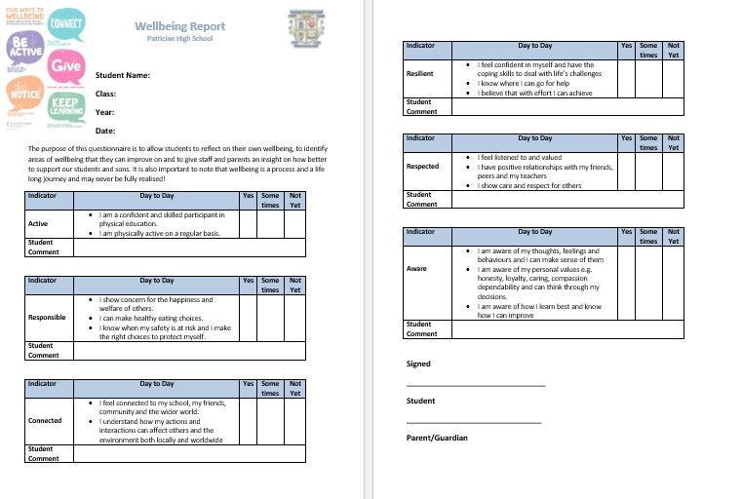

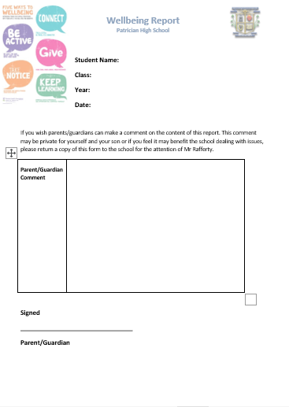

Review

This Policy was reviewed and updated in August 2025

Signed

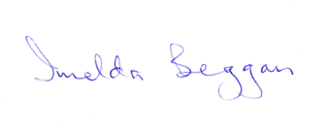

Principal Chairperson

____________________________________ __________________________________

