

MOBILE PHONE POLICY

MOBILE PHONES AND LEARNING:

When used in the correct manner, mobile phones can become a powerful source of communication and learning. While restrictions to their use must apply in some cases the Patrician high School recognises the powerful positive effect the mobile phone can have in a classroom environment.
Teachers may encourage the appropriate use of mobile phones in pursuit of learning, in the classroom and in other learning settings within the school.
To assist the school in implementing this policy parents/guardians are asked not to contact their sons by mobile phone during class time. Contact with the school should be made through the school reception (042 9661525) and a message can be relayed to you son if necessary.

RESTRICTIONS ON USE:

- Where students bring mobile phones to school, the phone must be switched off during class time, unless otherwise instructed by the teacher. The phone may be used by Senior Students, 4th to 6th Year, on the school premises during breaks (10:45-11:00 and 1:00-1:40) however students are required to make and receive essential calls outside of the building.

- All Junior Cyle students, 1st Year to 3rd Year, are required to store mobile device in a student locker for the duration of the school day. This includes student break times.

- If a phone goes off in class and it is a first time, then the phone may be confiscated by the teacher and returned by the deputy principal to the student at the end of that school day. If this happens for a second time, the phone is confiscated for 24 hours and is returned by the deputy principal on receipt of a note from a parent/guardian.

- If a student is using a phone in class without permission, for any reason, the phone will be confiscated for a period of 48 hours. The phone will be returned to the student by the deputy principal on receipt of a note from a parent/guardian. Should this happen for a second time in a school year the phone will be confiscated for a week.

- No photographs or recordings either video or audio can be made on the phone on the school premises. Using phones in such a way can seriously infringe on people’s privacy and rights. In some cases, a teacher may allow for recordings/pictures to be taken to assist with project work. Students found breaking the rule will be issued with a conduct note and will be liable for suspension.

- Incidents where students use mobile phones to bully others by sending or sharing offensive messages will be investigated under the Anti-Bullying policy of the school. It should be noted that it is a criminal offence to use a mobile phone to menace, harass or offend another person. As such, the school may consider it appropriate to involve the Gardai in such incidents.

- The use of snapchat, at any time while on school property or while attending a school event, is strictly forbidden. Any student found breaking this rule will have their mobile phone confiscated for a 4-week period.

Where a phone has been confiscated, all references to time in the above policy refer to school days. Therefore, if a phone is confiscated on a Friday and is due to be held for a period of 24 hours, this phone will not be returned until completion of the next school working day.
The school accepts no responsibility for lost, stolen or damaged mobile phones. The safety and security of mobile phones is wholly a matter for the student/parent.
The school reserve the right to view the content of a phone, in the presence of the student, to ensure it contains no image or content that may compromise a member of the school community.

Review

This Policy was reviewed and updated in August 2025

Signed

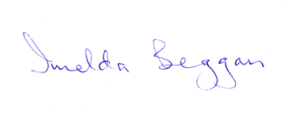
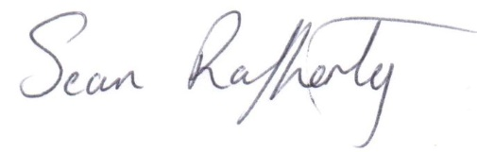
Principal Chairperson

____________________________________ __________________________________

